**Review Unit 5 Test**

**Vocabulary**

**Listening Comprehension Test**

**1 You will hear for seasons with the three months. Write down the number of the month in Chinese characters in the appropriate blanks. (12 points)**

1. 春天 chūn.tiān: 月 yuè， 月 yuè， 月 yuè



2. 夏天 xià.tiān: 月 yuè， 月 yuè， 月 yuè

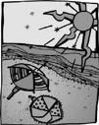

3. 秋天 qiū.tiān: 月 yuè， 月 yuè， 月 yuè

4. 冬天 dōng.tiān: 月 yuè， 月 yuè， 月 yuè

**Writing Test**

**3 Choose an adjective from the box that best describes the situations in the sentences.**

**Write the adjective on the line. (10 points)**

饿 è 热 rè 冷 lěng 糟糕 zāogāo 好玩儿 hăowánr

渴 kě 凉 liáng 讨厌 tăoyàn 温暖 wēnnuăn 好喝 hăohē

1. 我要吃冰淇淋。Wǒ yào chī bīng.qílín.

2. 我喜欢喝橙汁。*Wǒ* xǐ.huān hē chéngzhī.

3. 我的钱不见了！Wǒ.de qián bú jiàn .le!

4. 可以请你开暖气吗？*Kěyǐ qǐng* nǐ kāi nuănqì .ma?

5. 我真喜欢中国新年！Wǒ zhēn xǐ.huān Zhōng.guó Xīnnián!

6. 请给我一杯大杯的水。*Qǐng gěi* wǒ yì-bēi dàbēi .de shuǐ.

7. 今天是华氏七十七度。Jīn.tiān shì huáshì qī.shíqī-dù.

8. 这个周末我得在家念书。Zhèi-.ge zhōumò wǒ.de zài jiā niàn-shū.

9. 九月以后，不用吹空调了。Jiŭyuè yǐhòu, búyòng chuī kōngtiáo .le.

10. 汉堡包、炸鸡、薯条，我都要！Hànbăobāo、zhájī、shŭtiáo, wǒ

dōu yào!

**Language Patterns**

**Listening Comprehension Test**

**4 You will hear the weather forecast of seven different cities. Match the city with the letter of the corresponding weather. (7 points)**

|  |  |  |  |  |  |  |  |  |
| --- | --- | --- | --- | --- | --- | --- | --- | --- |
| 1. |  | 2. |  | 3. | 4. | 5. | 6. | 7. |
|  | 北京 |  | 蒙古 | 台湾 | 香港 | 成都 | 海南 | 哈尔滨 |

Běijīng

Ménggŭ

Táiwān

Xiānggăng

Chéngdū

Hăinán

Hā’ěrbīn

A. B. C. D. E. F. G.

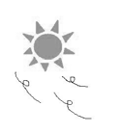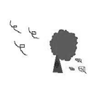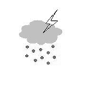

**5 You will hear two statements. Circle true or false according to what you hear.**

**Rewrite any false statements in Pinyin to make them true. (3 points)**

1. True / False

2. True / False

**6 You will hear six statements. Underline True if the statement matches the illustration**

**or False if it does not. (6 points)**

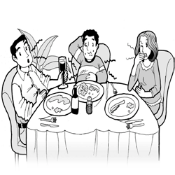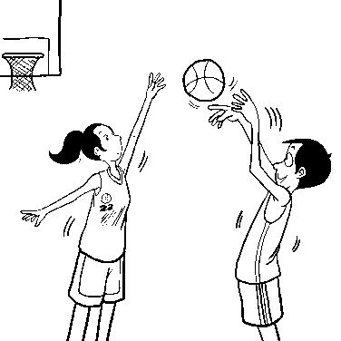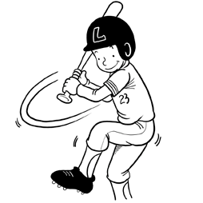

1. True / False 3. True / False 5. True / False

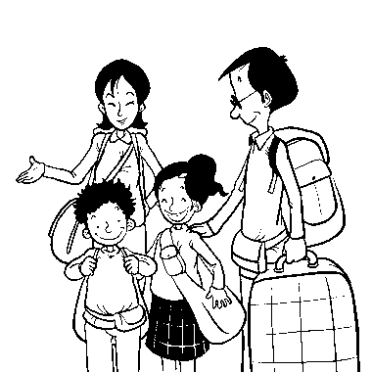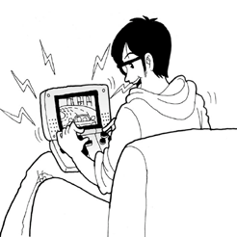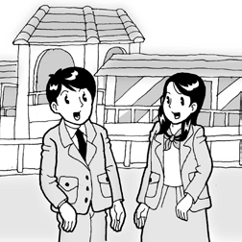

2. True / False 4. True / False 6. True / False

**Writing Test**

**7 Write the letter of the corresponding festival on the line to complete the sentences below. (5 points)**

1. 的时候.de shíhòu，大家吃粽子 dàjiā chī zòng.zi。

A. 清明节 Qīngmíngjié B. 中秋节 Zhōngqiūjié C. 端午节 Duānwŭjié

2. 的时候.de shíhòu，大家放鞭炮 dàjiā fàng biānpào。

A. 春节 Chūnjié B. 重阳节 Chóngyángjié C. 元宵节 Yuánxi āojié

3. 的时候.de shíhòu，爸爸送给妈妈一束花(a bouquet) bà.x sòng gěi mā.x yí-shù

huā。

A. 七夕 Qīxī B. 除夕 Chúxī C. 重阳节 Chóngyángjié

4. 的时候.de shíhòu，我们说“恭喜” dàjiā shuō “gōngxǐ”。

A. 除夕 Chúxī B. 春节 Chūnjié C. 冬至 Dōngzhì

5. 的时候.de shíhòu，全家人一起吃饭，晚饭一定有鱼 quán jiārén yìqǐ chī-fàn,

wănfàn yídìng yǒu yú 。

A. 除夕 Chúxī B. 春节 Chūnjié C. 中元节 Zhōngyuánjié

**8 Complete each sentence in Pinyin according to the illustration. (3 points)**

1. 因为

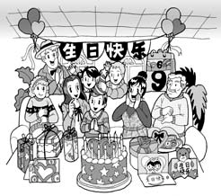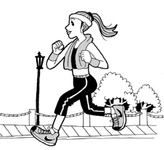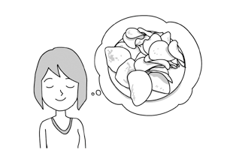

Yīn.wèi ， 所以很多人来我家 *suǒ*.*yǐ* hěn duō rén lái wǒ jiā。

2. 因为

Yīn.wèi ， 所以她很健康(*healthy*) *suǒ*.*yǐ* tā hěn jiànkāng。

3. 因为她要看电影 Yīn.wèi tā yào kàn diànyǐng， 所以 。

**9 Match each question in the right column with the corresponding response in the left**

**column. (6 points)**

ròu.

|  |  |  |
| --- | --- | --- |
| 1. | 你可以马上来吗？*Nǐ kě*yǐ  măshàng lái .ma? | D. 我一点儿也不喜欢肉。  Wǒ yì.diănr yě bù xǐ huān |
| 2. 你只吃牛肉吗？*Nǐ* zhǐ chī B. 不，他觉得太咸了。Bù, t niúròu .ma? tài xián .le. | | |
| 3. 他喜欢鸡汤面吧？Tā xǐ.huān C. 牛肉面又香又好吃。Niúrò  jītāngmiàn .ba? yòu xiāng yòu hăochī. | | |
| 4. 你很喜欢吃肉吧？*Nǐ hě*n xǐ.huān D. 得看那个时候几度。Děi chī ròu .ba? .ge shíhòu jǐ-dù. | | |
| 5. 牛肉面好吃吗？Niúròumiàn E. 除了牛肉，我也吃猪肉。  hăochī .ma? niúròu, *wǒ* yě chī zhūròu. | | |
| 6. 睡觉的时候，可以开空调吗？ F. 等一下，我在跟我妈妈说 | | |

ā jué.de

umiàn

kàn nèi-

Chú.le

Shuìjiào .de shíhòu, *kě*yǐ kāi kōngtiáo .ma?

话。

Děng yí.xià, wǒ zài gēn wǒ mā.x shuō-huà.

**10 Use the pattern “**一点儿也**/**都不 ***yì.diănr yě/ dōu bù”* to answer the following**

**questions in Pinyin. (6 points)**

1. 法文很难吧？Făwén hěn nán .ba?

2. 墨西哥菜很辣吧？Mòxīgē cài hěn là .ba?

3. 爷爷游泳很慢吧？Yé.x yóuyǒng hěn màn .ba?

4. 做香包很容易吧？Zuò xiāngbāo hěn róngyì .ba?

5. 芝麻冰淇淋很好吃吧？Zhīmá bīngqīlín hěn hăochī .ba?

6. 你昨天晚上两点睡，现在很累吧？Nǐ zuó.tiān wăn.shàng liăng-diăn shuì, xiànzài hěn

lèi .ba?

**11 Look at the calendar and answer the following questions in Pinyin. (10 points)**

五月 **Wŭyuè**

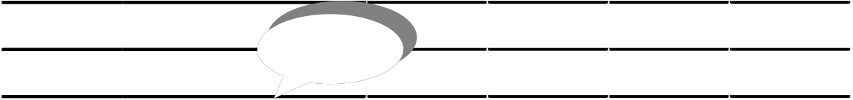

星期一

Xīngqīyī

星期二

Xīngqī’èr

星期三

Xīngqīsān

星期四

Xīngqīsì

星期五

Xīngqīwŭ

星期六

Xīngqīliù

星期日

Xīngqīrì

1 2 3 4 5

6 7 8 9 10 11 12

13 14 15 16 17 18 19

今天 jīn.tiān

20 21 22 23 24 25 26

27 28 29 30 31

1. 今天是几月几号？Jīn.tiān shì jǐ-yuè jǐ-hào?

2. 下下个月是几月？Xià xià-.ge yuè shì jǐ-yuè?

3. 上个月是四月吗？Shàng.ge yuè shì Sìyuè .ma?

4. 五月有多少天？Wŭyuè yǒu duōshăo tiān?

5. 这个月有几个周末？Zhèi-.ge yuè yǒu j ǐ-.ge zhōumò?

6. 今天是星期几？Jīn.tiān shì xīngqī-jǐ?

7. 大前天是星期日吗？Dàqián.tiān shì Xīngqīrì .ma?

8. 后天是不是二十五号？Hòu.tiān shì .bú shì èr.shíwŭ hào?

9. 上上个星期五是几号？Shàng shàng-.ge Xīngqīwŭ shì jǐ-hào?

10. 下个星期六还是五月吗？Xià-.ge Xīngqīliù hái shì Wŭyuè .ma?

**Proficiency Writing**

**12 You will hear five Chinese words. Write each word in Chinese characters. (5 points)**

1.

2.

3.

4.

5.

**Speaking**

**13 Role play the following situation with your teacher. (10 points)**

1. Greet your teacher. (1 point)

2. Say how the weather is today and ask what weather your teacher likes. (2 points)

3. Say what weather you like. (1 point)

4. Ask what season your teacher likes. (1 point)

5. Say the season you like and why (maybe because of something you like to do in that season or just because of the weather). (2 points)

6. Ask what Chinese festivals your teacher likes. (1 point)

7. Say what Chinese festivals you like and why. (2 points)

**Reading**

**14 Answer each question in Pinyin according to the information provided in the chart below. (5 points)**

|  |  |
| --- | --- |
| 柏林 Bólín (*Berlin*) | 多云时晴 duōyún shí qíng |
| 伦敦 Lúndūn (*London*) | 多云转阴有雨 duōyún zhuăn yīn yǒu yŭ |
| 巴黎 Bālí (*Paris*) | 晴时多云 qíng shí duōyún |
| 东京 Dōngjīng (*Tokyo*) | 晴转阵雨 qíng zhuăn zhèn yŭ |
| 纽约 Niŭyuē (*New York*) | 晴时多云转阵雨 qíng shí duōyún zhuăn zhèn yŭ |

1. 巴黎的天气怎么样？Bālí .de tiān.qì zěn.meyàng?

2. 伦敦是晴天吗？Lúndūn shì qíng.tiān .ma?

3. 东京下雪吗？Dōngjīng xià-xuě .ma?

4. 哪几个城市(*city*)会下雨？Nă jǐ-.ge chéngshì huì xià-yŭ?

5. 在柏林，阴天的时候比较多，还是晴天的时候比较多？Zài Bólín, yīn.tiān .de shíhòu

bǐjiào duō, hái.shì qíng.tiān .de shíhòu bǐjiào duō?

**Culture**

**15 Fill in the blanks in English to complete the sentences below. (6 points)**

1. The twelve animals of the Chinese zodiac are: the rat, ox, _ , rabbit,

, snake, horse, goat, , rooster, dog and, pig.

2. Fish is considered a lucky dish to have on Chinese New Year’s Eve because the homonym for the word fish in Chinese is .

3. In 1984, the Chinese government issued a law stating that the system must be used for lengths, weights, electricity, time, and speed.

4. is the oldest surviving imperial garden to be built in the world.

**16 Write T if the statement below is true or F if it is not. (4 points)**

1.

A lunar year is shorter than a year of the Western calendar.

2.

Chinese children are given red envelopes as gifts on Dragon Boat Festival.