4.1.7 Step-by-Step Truss Analysis Worksheet Answer Key

Procedure
In this activity you will calculate reaction and member forces for the truss system illustrated below. To ensure proper calculations and free body diagrams, it is essential that you follow each step in the procedure.

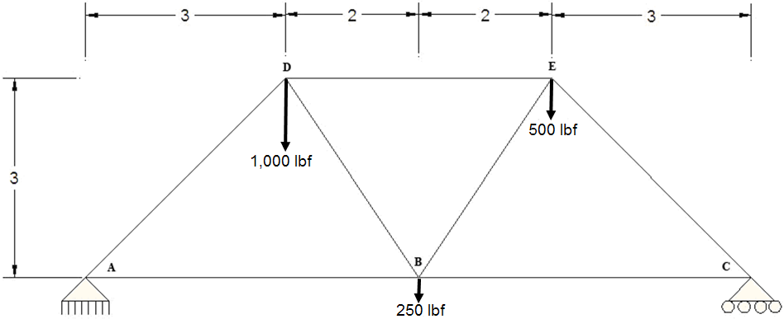

Calculate External Reaction Forces
x and y Reaction Force at Pin A and y Reaction Force at Roller C
- Draw a free body diagram for the entire truss structure illustrated above.
Make sure to include all known and unknown angles, forces, and distances. Calculate and determine all angles using trigonometry and geometry.
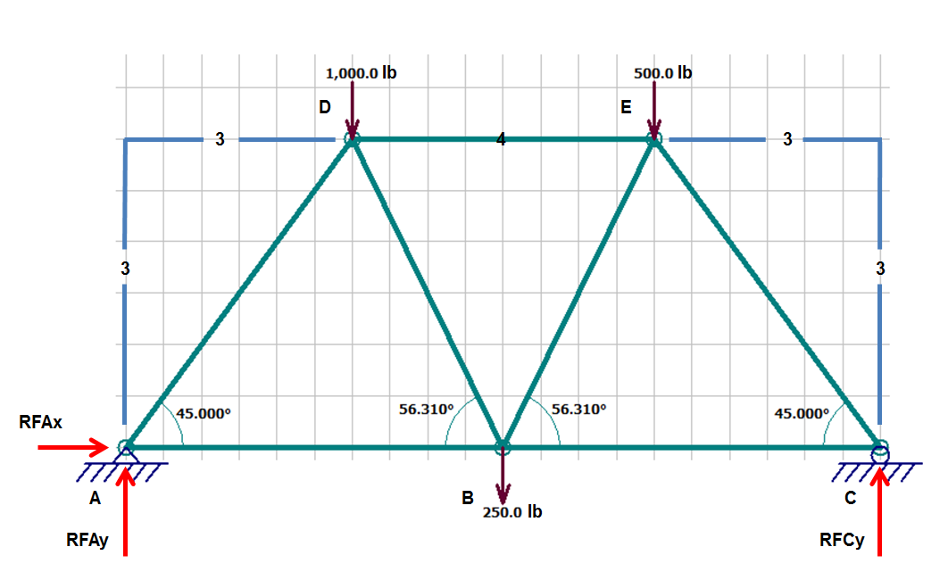  (1 Box = .5 Units) | Algebra hints:  sin θ = O/H  cos θ = A/H  tan θ = O/A  a² + b² = c²

- Calculate reaction forces at the roller and pin connections.
  - List static equilibrium equations. Hint: Σ (They all involve summations)
ΣF_{x} = 0 |  | ΣF_{y} = 0 |  | ΣM = 0

  - List all known and unknown forces acting and reacting on the truss structure. Label direction of force with an arrow.
    - Forces in the x direction
R_{Ax}→

    - Forces in the y direction
R_{Ay} ↑ |  | R_{Cy} ↑ |  | 1000 lb ↓ |  | 500 lb ↓ |  | 250 lb ↓

    - Moment Forces – Determined from Pin A
Formula review:  M = Fd |  | 1000 x 3  cw = (-) |  | 250 x 5  cw = (-) |  | 500 x 7  cw = (-) |  | R_{Cy} x 10  ccw = (+)
  - Use the moment static equilibrium equation acting upon pin A to solve for R_{CY}.
ΣM = 0 |  | -3000 lbf -1250 lbf -3500 lbf + (10 ft x R_{Cy}) = 0
Equation |  | Substitution

10 ft x R_{Cy} = 7750 lb |  | R_{Cy} = 775 lb
Simplification |  | Solution

  - Solve for unknown reaction force in the x direction (R_{Ax}).
Use the sum of forces in the x direction equilibrium equation.
ΣF_{x} = 0 |  | R_{Ax} = 0 |  | R_{Ax} = 0
Equation |  | Substitution |  | Solution

  - Solve for unknown reaction forces in the y direction.
Use the sum of forces in the y direction equilibrium equation.
ΣF_{y} = 0 |  | R_{Ay} + R_{Cy} - 1000 lb - 500 lb - 250 lb = 0
Equation |  | Substitution

R_{Ay} + 775 lb = 1750 lb

R_{Ay} = 975 lb
Solution

  - Draw a free body diagram for the entire truss system illustrated on page 1.
Make sure to include your calculated support reactions (1 Box = .5 Units).
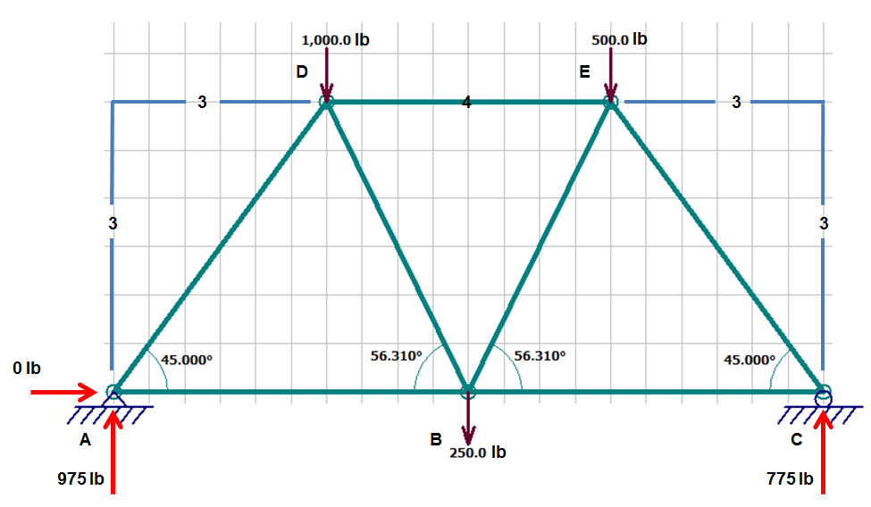
Calculate Individual Truss Member Forces
- Calculate member forces AD and AB.
  - Draw the free body diagram for joint A.
Make sure to include all known and unknown angles and forces (including x and y vector components). Do not include lengths.

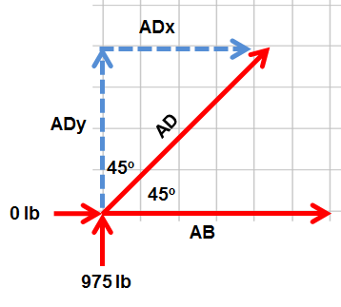
  - Use SOH CAH TOA to express AD_{X} and AD_{Y} in terms of AD.
    - Calculate AD_{X}
$$sin θ= \frac{Opp}{Hyp}$$ |  | $$\sin{{45}^{0}}= \frac{{AD}_{x}}{AD}$$ |  | AD_{X} = AD x sin 45°
Equation |  | Substitution |  | Solution

    - Calculate AD_{Y}
$$cos θ= \frac{Adj}{Hyp}$$ |  | $$\cos{{45}^{0}}= \frac{{AD}_{y}}{AD}$$ |  | AD_{Y} = AD x cos 45°
Equation |  | Substitution |  | Solution

  - List all known and unknown forces.
Label direction of force with an arrow.
    - Forces in the x direction
0 lb → |  | AB → |  | AD x sin 45°→

    - Forces in the y direction
 |  | 975 lb ↑ |  | AD x cos 45°

  - Use static equilibrium equations to solve for AD and AB.
    - Solve for AD by calculating y-direction static equilibrium.
ΣF_{y} = 0 |  | 975 lb + (AD x cos 45°) = 0 |  | AD x cos 45° = - 975 lb
Equation |  | Substitution |  | Simplification

 |  | $$AD= \frac{- 975 lb}{\cos{{45}^{0}}}$$ |  | AD = –1378.86 lb  Note: The answer is negative, so change the assumed direction. The member is under compression.
 |  | Simplification |  | Solution

    - Solve for AB by calculating x direction static equilibrium.
ΣF_{x} = 0 |  | 0 lb + AB + (AD x sin 45°) = 0 |  | AD x sin 45° = –AB
Equation |  | Substitution |  | Simplification

 |  | –1378.86 lb x sin 45° = –AB |  | AB = 975 lbf
 |  | Substitution – Insert calculated AD value |  | Solution
  - Update the joint A free body diagram with calculated forces for AD and AB.

- Calculate CB and CE.
  - Draw the free body diagram for joint C.
Make sure to include all known and unknown angles and forces (including x and y vector components). Do not include lengths.

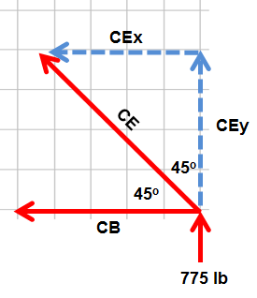
  - Use SOH CAH TOA to express CE_{x} and CE_{y} in terms of CE.
    - Calculate CE_{x}
$$sin θ= \frac{Opp}{Hyp}$$ |  | $$\sin{{45}^{0}}= \frac{{CE}_{x}}{CE}$$ |  | CE_{x} = CE x sin 45°
Equation |  | Substitution |  | Solution

    - Calculate CE_{Y}
$$cos θ= \frac{Adj}{Hyp}$$ |  | $$\cos{{45}^{0}}= \frac{{CE}_{y}}{CE}$$ |  | CE_{y} = CE x cos 45°
Equation |  | Substitution |  | Solution

  - List all known and unknown forces.
Label direction of force with an arrow.
    - Forces in the x direction
 |  | CB ← |  | CE x sin 45°←

    - Forces in the y direction
 |  | 775 lb ↑ |  | CE x cos 45° ↑

  - Use static equilibrium equations to solve for AD and AB.
    - Solve for CE by calculating y direction static equilibrium.
ΣF_{y} = 0 |  | 775 lb + (CE x cos 45°) = 0 |  | CE x cos 45° = –775 lb
Equation |  | Substitution |  | Simplification

CE = –1096.02 lb
Note: The answer is negative, so change the assumed direction. The member is under compression.
Solution

    - Solve for CB by calculating x direction static equilibrium.
ΣF_{x} = 0 |  | CB + (sin 45° x CE) = 0 |  | –CB = sin 45° x CE
Equation |  | Substitution |  | Simplification

 |  | –CB = sin 45° x –1096.02 lb |  | CB = 775 lb  The member is under tension.
 |  | Substitution – Insert calculated CE value |  | Solution

  - Update joint C free-body diagram with calculated forces for CE and CB.

- Calculate EB and ED
  - Draw the free-body diagram for joint E.
Make sure to include all known and unknown angles and forces (including x and y vector components). Do not include lengths.
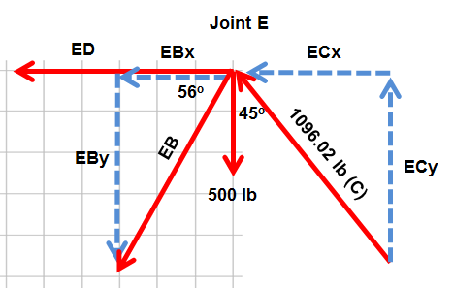

  - Use SOH CAH TOA to express EB_{x} and EB_{y} in terms of EB.
    - Calculate EB_{y}
$$sin θ= \frac{Opp}{Hyp}$$ |  | $$\sin{{56}^{0}}= \frac{{EB}_{y}}{EB}$$ |  | EB_{y} = sin 56° x EB
Equation |  | Substitution |  | Solution

    - Calculate EB_{X}
$$cos θ= \frac{Adj}{Hyp}$$ |  | $$\cos{{56}^{0}}= \frac{{EB}_{x}}{EB}$$ |  | EB_{x} = cos 56° x EB
Equation |  | Substitution |  | Solution

  - List all known and unknown forces.
Label direction of force with an arrow.
    - Forces in the x direction
ED ← |  | 775 lb ← |  | cos 56° x EB ←

    - Forces in the y direction
500 lb ↓ |  | 775 lb ↑ |  | sin 56° x EB ↓

  - Use static equilibrium equations to solve for EB.
    - Calculate y direction static equilibrium.
ΣF_{y} = 0 |  | –500 lb + 775 lb – (sin 56° x EB) = 0 |  | 275 lb – (sin 56° x EB) = 0
Equation |  | Substitution |  | Simplification

275 lb = sin 56° x EB |  | $$EB= \frac{ 275 lb}{\sin{{56}^{0}}}$$ |  | EB = 331.71 lb
Substitution |  | Simplification |  | Solution

    - Calculate x direction static equilibrium.
ΣF_{X} = 0 |  | ED + 775 lb + (cos 56° x EB) = 0 |  | ED + (cos 56° x EB) = –775 lb
Equation |  | Substitution |  | Simplification

ED + (185.27 lb) = –775 lb |  | ED = –185.27 lb –775 lb = 0 |  | ED = –960.27 lb  The member is under compression.
Substitution |  | Simplification |  | Solution
  - Update joint E free body diagram with calculated forces for EB and ED.

- Calculate DB
  - Draw the free body diagram for joint D.
Make sure to include all known and unknown angles and forces (including x and y vector components). Do not include lengths.
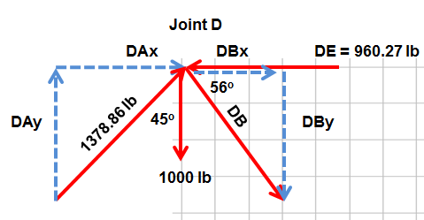

  - Use SOH CAH TOA to express DB_{x} and DB_{y} in terms of DB.
    - Calculate DB_{y}
$$sin θ= \frac{Opp}{Hyp}$$ |  | $$\sin{{56}^{0}}= \frac{{DB}_{y}}{DB}$$ |  | DB_{y} = sin 56° x DB
Equation |  | Substitution |  | Solution

    - Calculate FDB_{X}
$$cos θ= \frac{Adj}{Hyp}$$ |  | $$\cos{{56}^{0}}= \frac{{DB}_{x}}{DB}$$ |  | DB_{x} = cos 56° x DB
Equation |  | Substitution |  | Solution
  - List all known and unknown forces.
Label direction of force with an arrow.
    - Forces in the x direction
975 lb → |  | 960.27 lb ← |  | cos 56° x DB →

    - Forces in the y direction
975 lb ↑ |  | 1000 lb ↓ |  | sin 56° x DB ↓

  - Use static equilibrium equations to solve for DB.
    - Solve for DB by Calculating y direction static equilibrium.
ΣF_{y} = 0 |  | 975 lb – 1000lb – (sin 56° x DB) = 0 |  | 25 lb = – (sin 56° x DB)
Equation |  | Substitution |  | Simplification

$$DB= \frac{25 lb}{- sin{{56}^{0}}}$$ |  | DB = –30.05 lb
Simplification |  | Solution

  - Update joint D free body diagram with calculated forces for DB and DE.

Draw Completed Free Body Diagram
- Draw a completed free body diagram for the entire truss structure using all calculated reaction and member forces.

