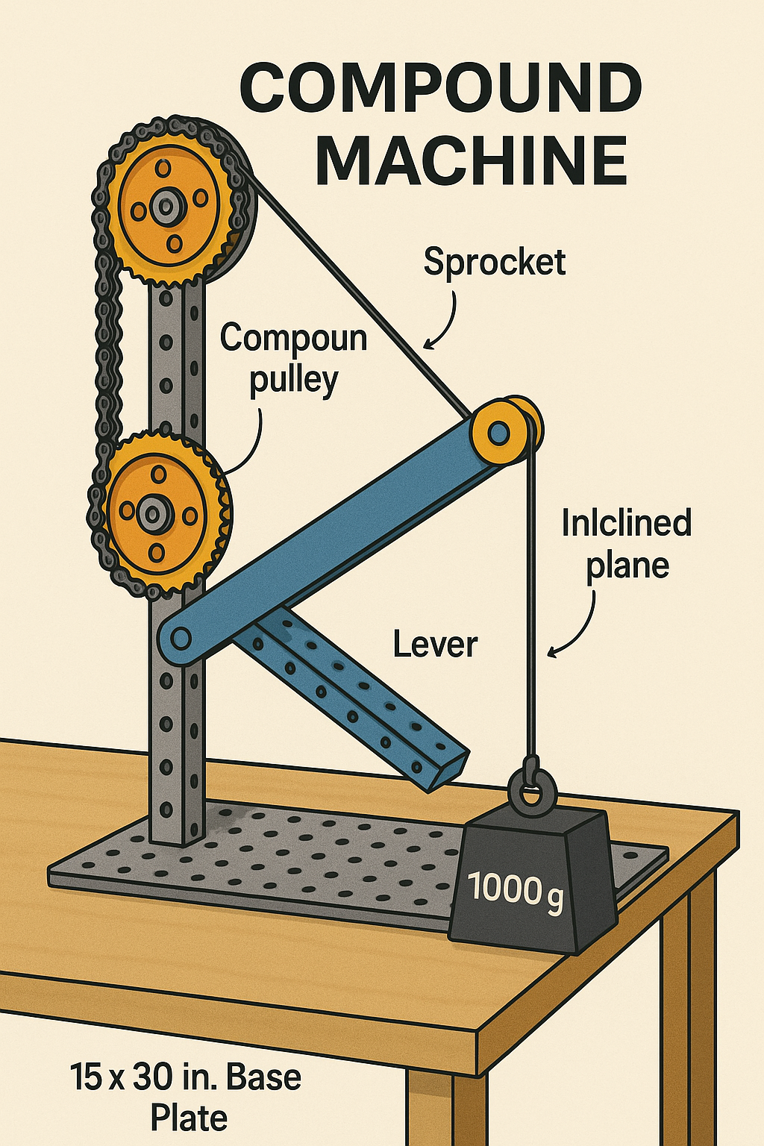
PLTW Compound Machine Project — Student Guide
Objective: Build a compound machine using VEX parts that transports a payload (such as a 1000-gram weight) from the floor to a tabletop (≥50 cm high). The machine must move the payload continuously without human intervention and must include at least 3 different simple machines. Creative variations of this challenge are welcome with instructor approval.
Footprint: The machine must fit entirely on the 15 × 30 in. VEX base plate.
Materials: Only VEX components are allowed. Exceptions: string, rubber bands, and tape as connectors or tension elements. No other parts.
Documentation: All notes, sketches, calculations, tests, and reflections must be kept in your engineering notebook. Nothing should be submitted separately.

Steps to Success

1. Define the Problem & Constraints
- Write a clear statement of what your machine will do.
- List criteria for success (payload height, smooth motion, safety, etc.).
- Record everything in your engineering notebook.

2. Research & Inspiration
- Look at examples of compound machines.
- Record ideas from videos, books, or websites.
- Cite your sources in your notebook.

3. Ideation & Planning
- Make 4+ sketches showing different ideas in your notebook.
- Use a selection matrix to choose the best design.
- Plan your build timeline in the notebook.

4. Build Mechanisms & Ensure Payload Transport
- Include 3+ different simple machines (lever, pulley, wheel/axle, inclined plane, screw, wedge).
- Machines must work together to move the payload.
- Ensure the payload moves from start to finish without hand assistance.
- Record your design notes in the notebook.

5. Calculations & Analysis
- Calculate IMA (ideal mechanical advantage) and AMA (actual mechanical advantage).
- Compute efficiency.
- Record gear or pulley ratios.
- Compare predicted vs. actual performance in your notebook.

6. Build Quality & Safety
- Build sturdily and neatly.
- All parts must stay on the VEX base plate.
- Take notes on any construction challenges or adjustments.

7. Testing & Iteration
- Test your machine multiple times.
- Record data in tables or graphs in your notebook.
- Make changes and improvements based on test results.
- Document each iteration.

8. Documentation
- Keep a dated, legible engineering notebook.
- Include sketches, parts lists, BOM (bill of materials), calculations, test results, and reflections.
- This is the only place for your project documentation.

9. Communication & Presentation
- Prepare a short demo showing payload transport.
- Explain your design process using visuals from your notebook.
- Be ready for questions.

10. Teamwork & Professionalism
- Assign roles fairly.
- Work collaboratively.
- Meet deadlines and stay on task.
- Record your team roles and contributions in your notebook.

Quick Checklist (for students, all in notebook)
- Problem statement & success criteria
- Research notes & citations
- 4+ sketches + selection matrix
- Final digital detailed drawings / CAD / exploded view
- Parts list (VEX components only)
- IMA, AMA, efficiency, gear/pulley ratios
- Testing data tables & graphs
- Iteration notes
- Final prototype photos/video showing payload transport
- Presentation slides/poster & demo plan

