VC Connect
Untangling Your Apple ID - Tasks

Supplies
Mac computer
Apple device (iPhone, iPad, or iPod)

Task #1 - Find all your Apple ID Usernames and Passwords

Apple ID #1
Nickname _________________________________________

Username _________________________________________

Password _________________________________________

Apple ID #2
Nickname _________________________________________

Username _________________________________________

Password _________________________________________

Apple ID #3
Nickname _________________________________________

Username _________________________________________

Password _________________________________________

Task #2
A – Decide which Apple ID/iCloud you would like as your primary account. (I do not recommend
using your work Apple ID.)

B – Determine which iCloud account is being used as the main account on each of your devices.
- On your Mac computer, go to System Preferences – Internet Accounts
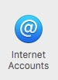


- On an iPhone or iPad, go to Settings – iCloud

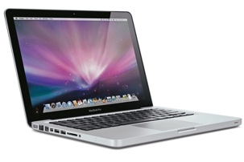

VCS Mac Main iCloud _________________________________________



Home Mac Main iCloud _________________________________________

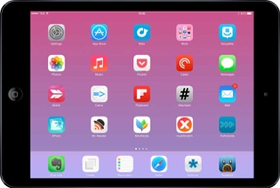

iPad Main iCloud _________________________________________

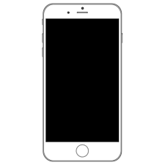

iPhone Main iCloud _________________________________________

Task #3 – Sign on to each iCloud account online to determine which Contacts, Notes, and Reminders live with which iCloud account.

Go online to – iCloud.com

Notes –

Example Account Setup
(on my work Mac computer)

Main iCloud account Additional iCloud Account
(Uses my Warriorlife Apple ID)
(Note that Contacts, Calendar, and Reminders (Note that Mail is not active as I do not wish to
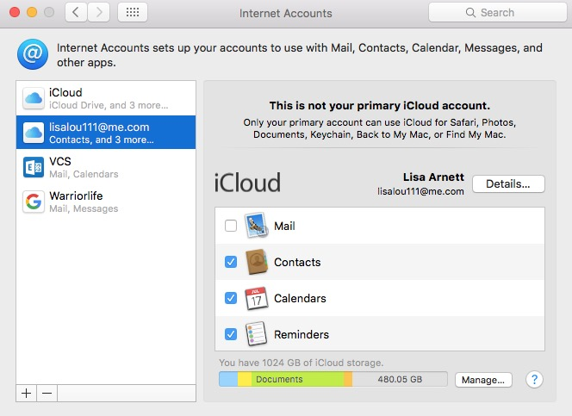
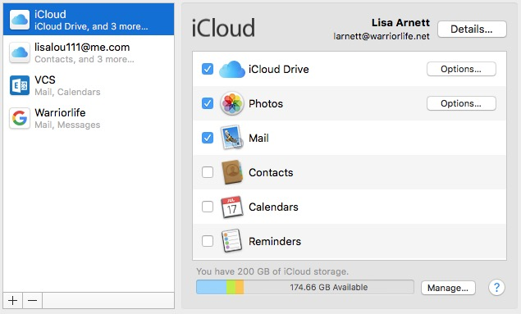
are not active for this account.) receive personal email on my school computer.)

Additional Email and Calendar Account Additional Email and Messages Account
(VCS Exchange) (Warriorlife Account)
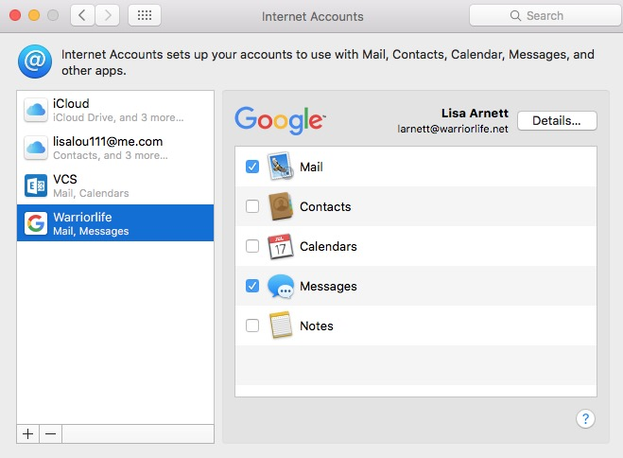
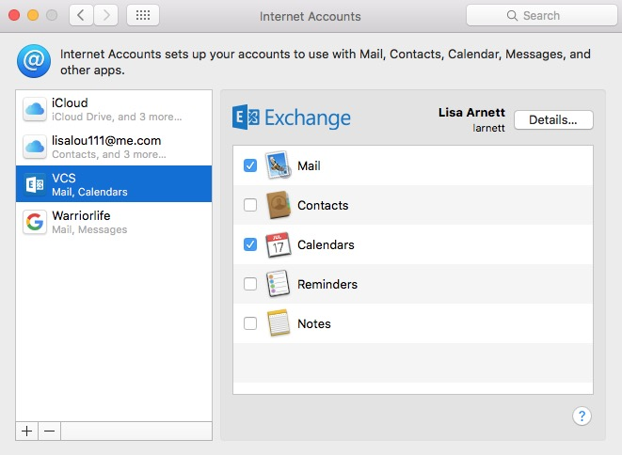

Note – Only one account should have Contacts, Notes, and Reminders activated.

Task #4 Contacts – Consolidate your Contacts to one iCloud account.
This job is best done on a Mac computer.
1 – Open the Contacts app.
2 – Go to Accounts.
3 – Click on Contacts for all accounts.
4 – From the Contact app, drag each individual contact to a folder on your desktop.
5 – Delete all contacts in the Contacts app.
6 – Go to Accounts.
7 – Turn off all Contacts in each account except the account that you have chosen to be your overall main iCloud account.
8 – Drag all the .vcf cards that you saved to the folder on the desktop to your Contacts app.
9 – Go to all other devices and turn off Contacts for all but the one iCloud account.
This is the only time you will need to untangle your Contacts if you keep your other accounts off.

Task #5 Notes – Consolidate your Notes to one iCloud account.
This is more laborious.
1 – Copy the text from each Note in each iCloud account to a common Word document.
2 – Turn off all but the one Note account on your device.
3 – Create new Notes from the Word document in the one account.
4 – Turn off all but the one Note account on each of your other devices.
This is the only time you will need to untangle your Notes if you keep your other accounts off.

Task #6 Calendar – Coordinate your Calendar accounts.
It is optimal to only have one iCloud calendar account. Yet, because the VCS Exchange account is responsible for sending and receiving invitations for meetings, it also needs to be turned on.
This job is best done on a Mac computer.
1 – Open the Calendar app.
2 – Go to Calendar – Accounts.
3 – Click on all Calendar accounts.
4 – View the accounts on the left.
5 – Uncheck the Exchange account.
6 – Create your sub accounts within your main iCloud account.
You may create different sub calendars within the one account. These can be turned on and off with a checkmark.
7 – Move all iCloud calendar events that are not Exchange dates to one iCloud account.
8 – Turn off all iCloud calendar accounts except the main iCloud account. (You should have two Calendar accounts active, Exchange and your main iCloud account.)
9 – Check the Exchange account.
10 – Subscribe to additional calendars by going to File – New Calendar Subscription.

Task #7 Reminders – Consolidate your Reminders to one iCloud account.
1 – These need to be reassigned to one iCloud account.

