VC Connect
Ninja Microsoft Excel Skills
Tasks

Task #1 – Workbook Organization – Worksheet verses Workbook
- Open the document – VC Connect Excel Student Workbook.
- Rename the following tab (Tabs may not contain spaces):
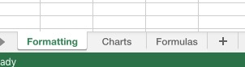
Sheet1 – Charts
Sheet2 – Formatting
Sheet3 – Formulas
- Delete the tab Sheet4.

Task #2 – Formatting Cells
- Open the Charts tab.
- Type the following:
In cell B1 – January
In cell C1 – February
In cell D1 – March
- Click on cell B1.
- Drag across until cells B1, C1, and D1 are chosen.

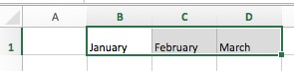
- Grab the heavy square at the bottom right and drag across to column M.

- Highlight columns A-M.
- Double click on one of the dividing lines between the columns. (This formats the column width to match the data in the column.)
- Highlight them again. Drag one of the divider lines to a particular width. (This will make all of the column widths match.)

- In cell A2, type “Sales”
- In row 2, for each month, type in a number. It does not matter what the numbers are.
- Click on the number “2” to choose the entire row 2.
- Right click on the “2” or press ⌘ + 1 to get to the formatting screen.
- Choose Format Cells then choose Currency and OK.

Task #3 – Charts
- Select A1 to M2
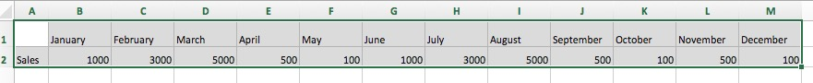

- Choose Insert from the top bar and then click Recommended Charts
- Click on Clustered Column.
- (Note how the chart is essentially a picture that can be moved around. Drag by the four arrows.)
- Change the cell A2 to “JH Sales” – (note how it changes the title in the graph).

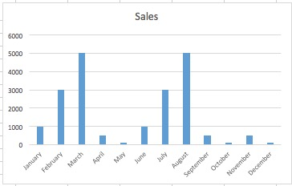

- Type “HS Sales” in cell A3.
- In row 3, for each month, type in a number. (It does not matter what the numbers are.)
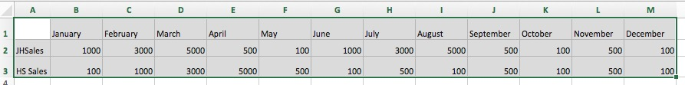
- Highlight cells A1 – M3.

- Choose Insert from the top bar and then click Recommended Charts
- Click Line
- Click Chart Title
- Change to “Skyway Sales”

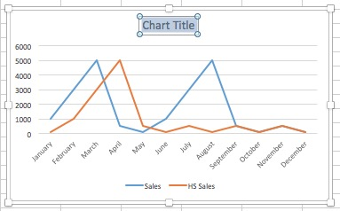

Task #4 – Printing Set Up
Choose the area that you would like to show on your printed sheet.
Note the dotted lines showing you the pages that will print.

Format the sheet to print the top and side bars on each page.
Go to –
File
Page Set Up
Sheet
Rows to repeat at top: $1:$1 (Type this or click on the “1” on the spreadsheet)
Columns to repeat at left: $A:$A (Type this or click on the “A” on the
Spreadsheet.)
Print

*** To keep the top row visible at all times when scrolling, select the row below your information row(s) – Go to – Window – Freeze Panes

Task #5 – Formatting
- Go to the web and go to vcs.net – Faculty and Staff – Marketing Office – VCS Logos.
Copy the logo from your school to your desktop.
- Go back to Excel.
- Click on the formatting tab.
- The following text should read:
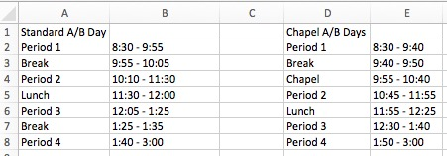

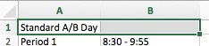
- Choose cells A1 and B1.

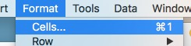
- In the top bar, choose Format – Cells.

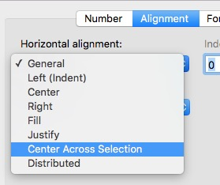
- From the Format Cells window, choose
Center Across Selection
- In the same window, in the Vertical
alignment drop down, choose – Center
- Repeat with cells D1 and E1.

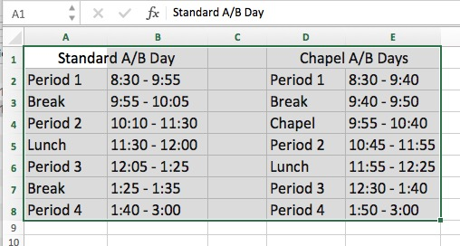
- Choose A1 – E8.
- Double click on the line between “E” and “F” – this will automatically make the columns just wide enough for the information located in them.
(You will then want to go in and make “B” and “E” larger)

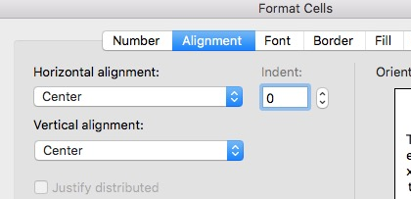
- Choose A2 – E8 – Go to:
Format Cells
Alignment
Horizontal alignment – Center
Vertical alignment – Center

- Shrink the width of column C by dragging the line to the right of the letter “C” in the column heading.

- Choose A1 to E8.

- Edit – Copy (or command + c).

- Open a blank Word document.

- Make a few returns at the top to give yourself some room.

- Paste what you have copied – Edit – Paste (command + V).

- You may have to make some adjustments to the cell size by dragging the line between the columns.

- Choose from Period 1 to 1:40 – 3:00.
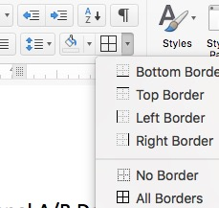
- Make sure you are on the “Home” tab and choose the border selector – all cells.

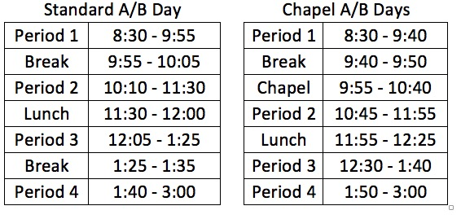
- Do the same for the second bank of times.

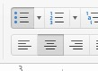
- Bold the titles “Standard A/B Day” and “Chapel A/B Days”

- Choose all and click on the “center” icon.

- Click on View then choose Header and Footer

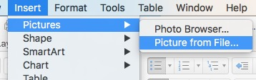
- With your cursor in the header, click on
Insert – Pictures – Picture from File

- Choose the logo you saved to your desktop.

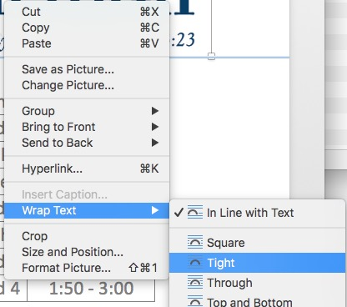
- Right click on the picture. Choose – Wrap text – Tight (or you may choose In Line with Text and then center the text).

- Drag the picture where you would like it and resize by pulling/pushing on a corner of the picture once it is chosen.

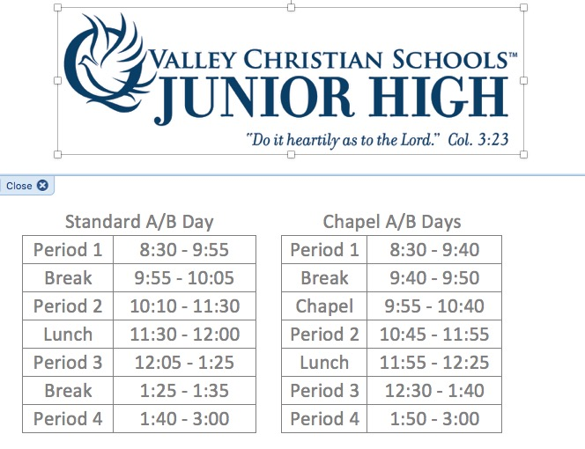

Formula Tips
(If there is time…)

- = is the clue to any formula

  - Addition is +
  - Subtraction is –
  - Multiplication is *
  - Division is /

- Autosum

- To multiply and divide Type in a cell =(21*2)/4 Press return (Did you get the answer, 11?)

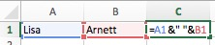
- To combine two cells

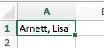
- To break up a cell into two cells

Highlight the cell.
Under the Data tab, choose Text to Columns
In the pop up box, choose Delimited – Next
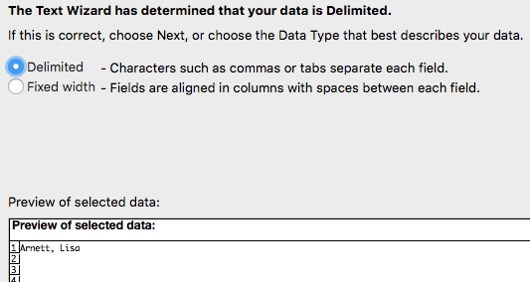

Choose Comma – Next
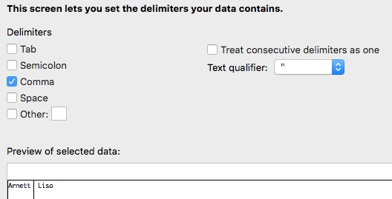

Choose General – Finish
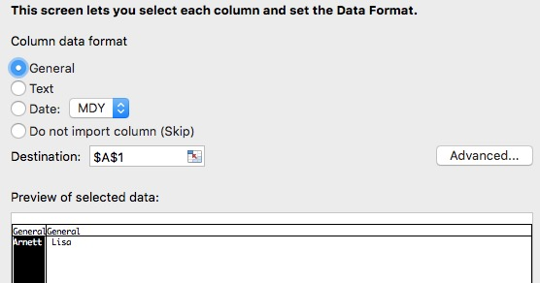

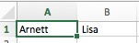
Voila!

