VCHS

Mandarin II 2020-2021

The Summer Work ( Packet #1)

Review for Level 1 Unit 1 -6
The Language Patterns

Name( 姓名): ________________

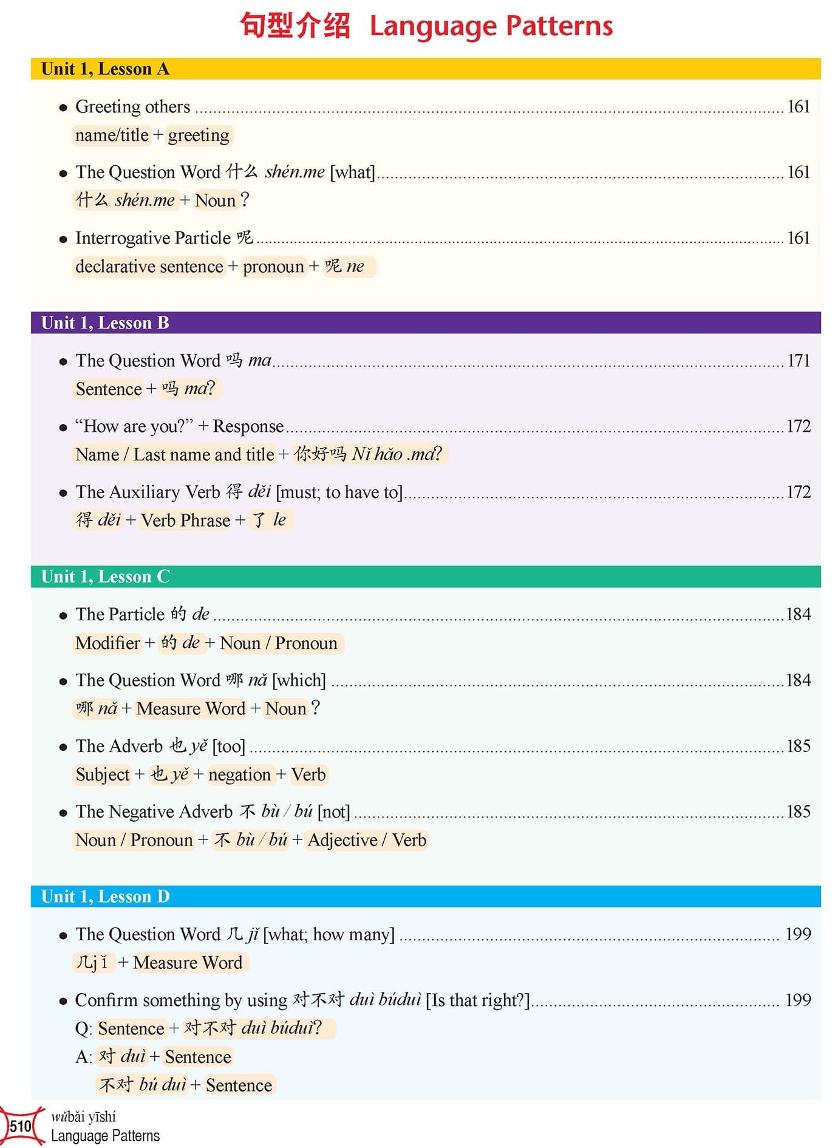
Mandarin I

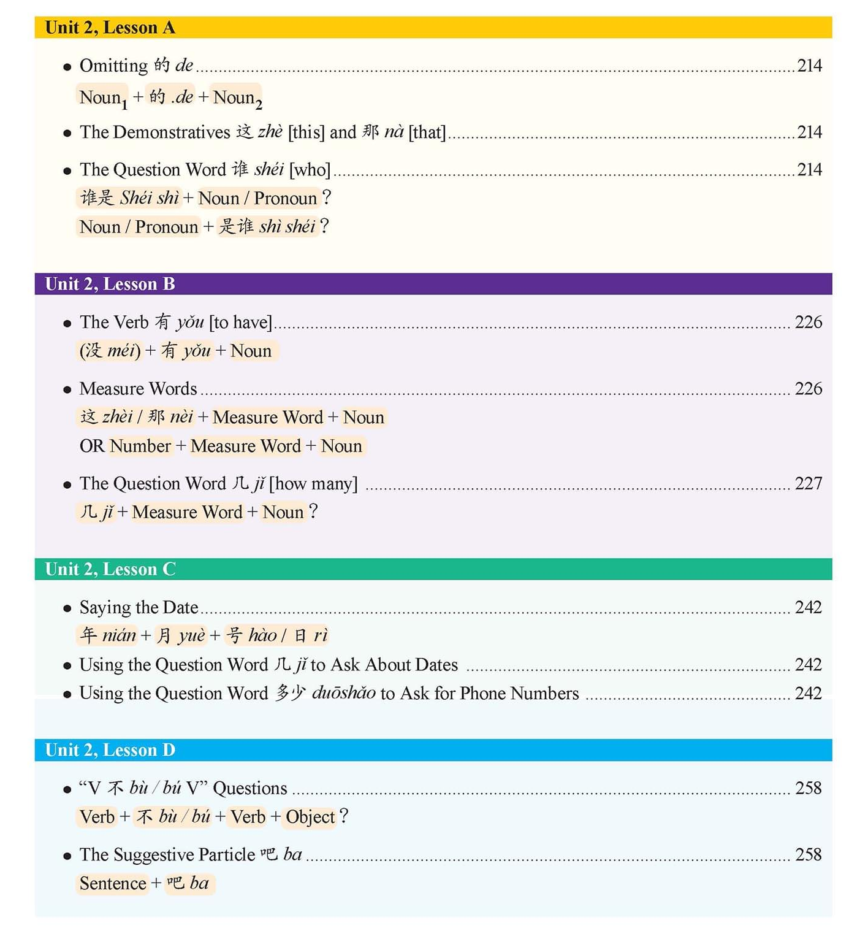

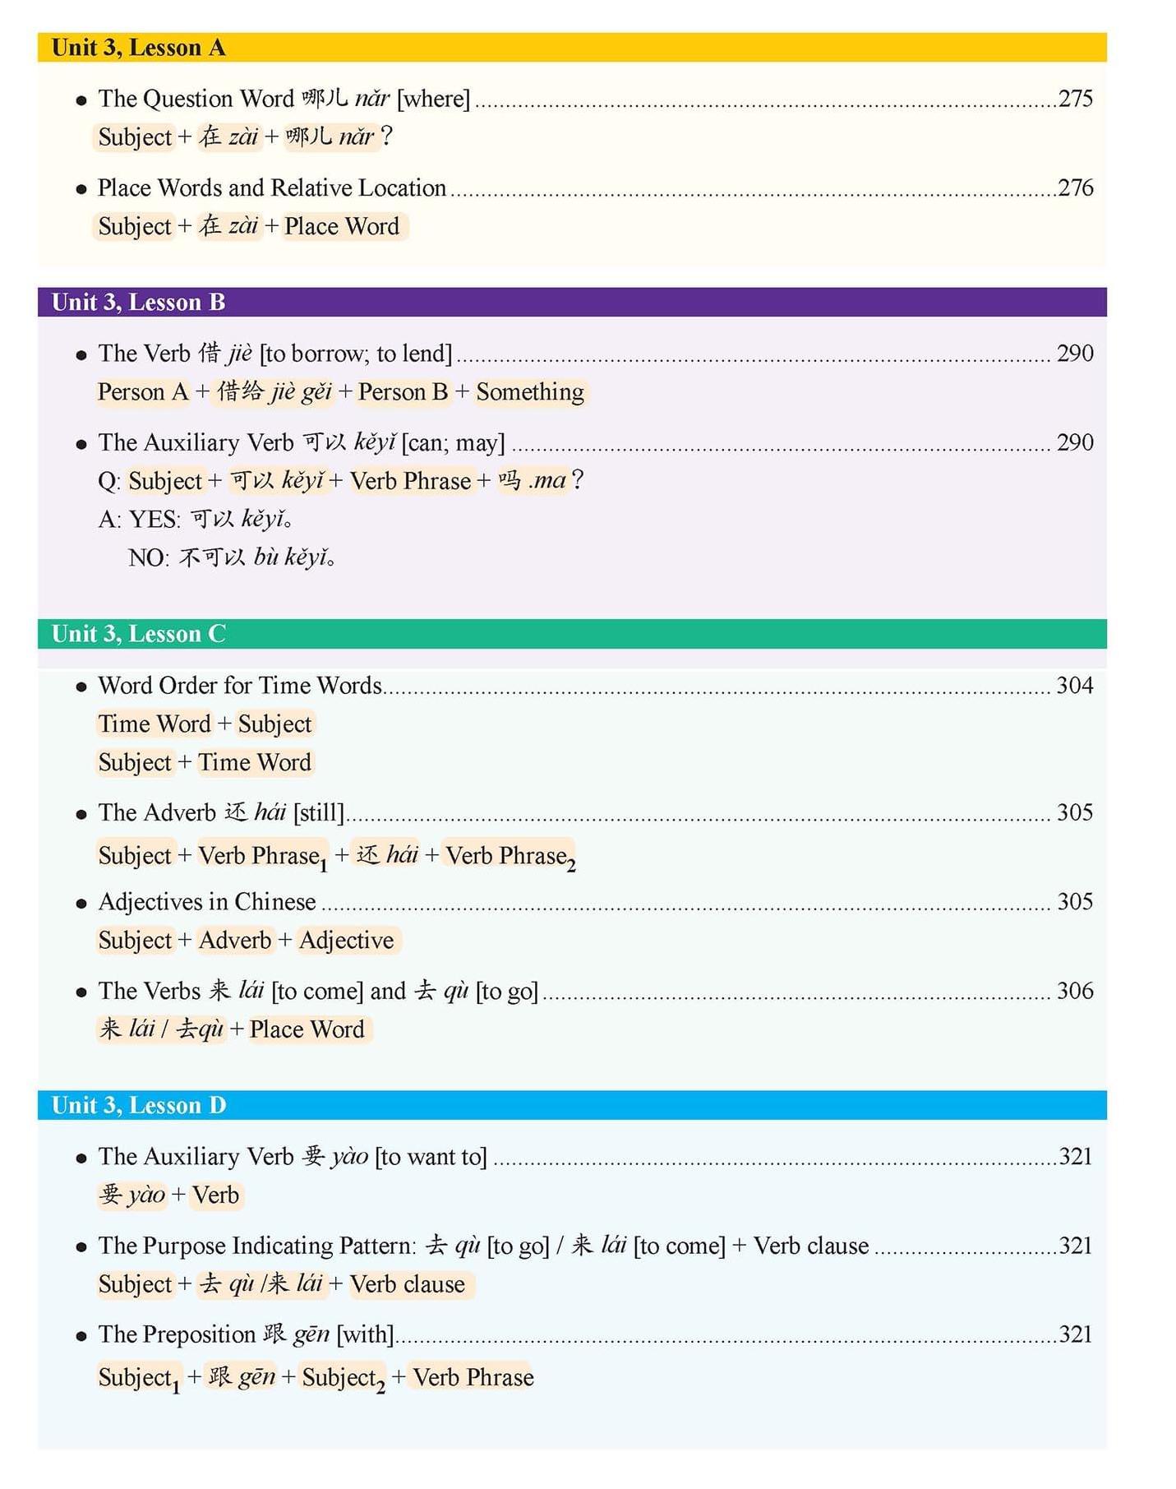

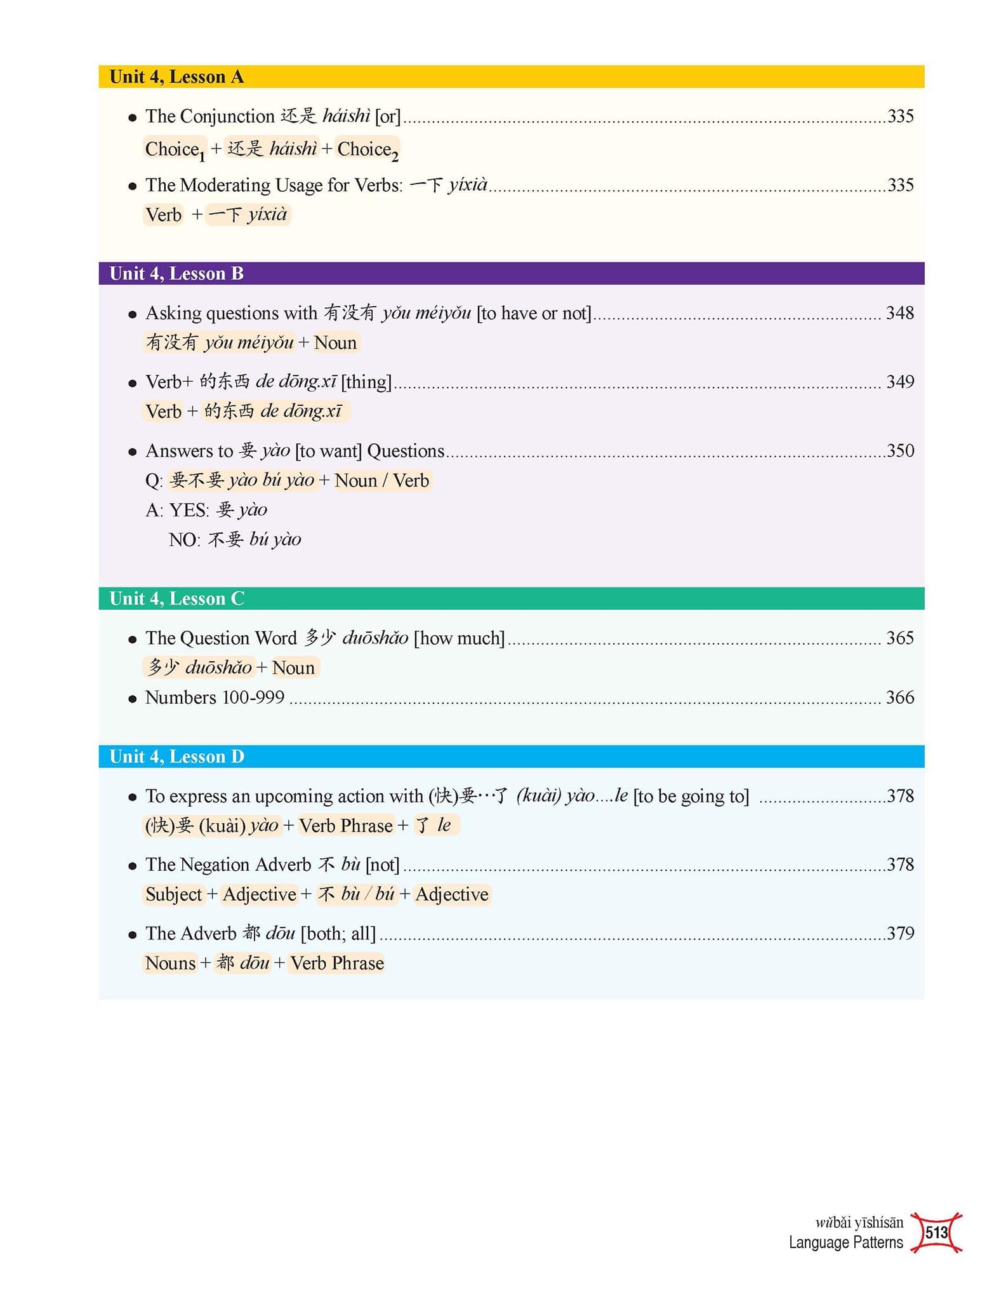

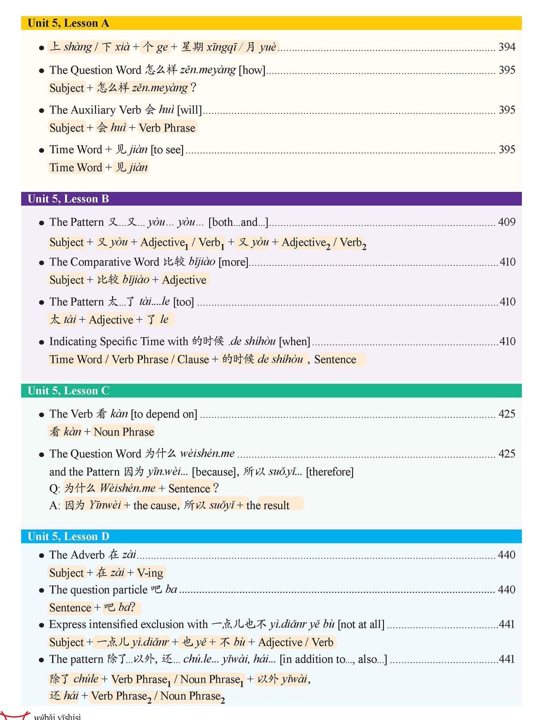

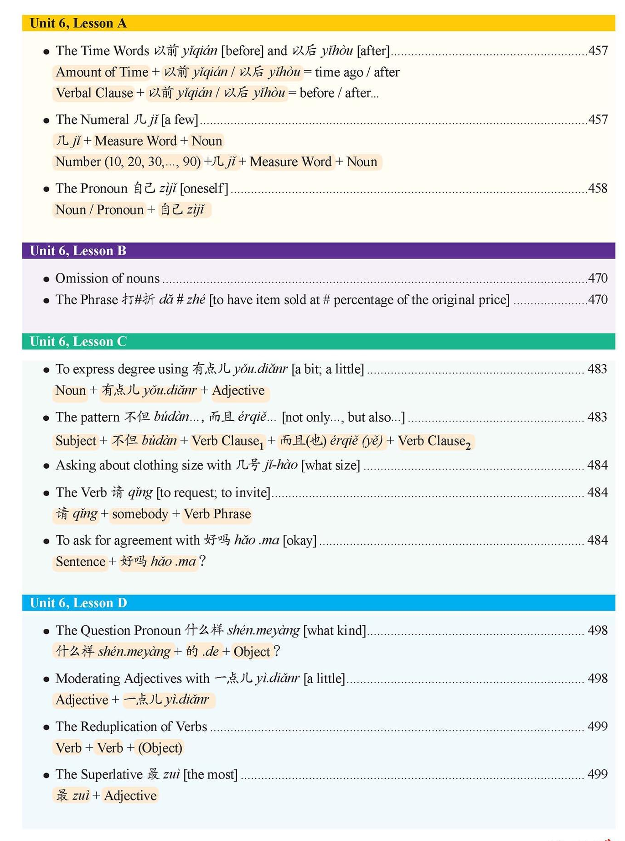

_______________________________________________________________________________

__________________________________________________________________________________

___________________________________________________________________________________

_______________________________________________________________________________

__________________________________________________________________________________

___________________________________________________________________________________

Study the review packet above for each Unit, please make at least two sentences for each Language patterns:
Unit 1
______________________________________________________
______________________________________________________
______________________________________________________
______________________________________________________
______________________________________________________
______________________________________________________
______________________________________________________
______________________________________________________
______________________________________________________
______________________________________________________
______________________________________________________
______________________________________________________
______________________________________________________
______________________________________________________
______________________________________________________
______________________________________________________

Unit 2

______________________________________________________
______________________________________________________
______________________________________________________
______________________________________________________
______________________________________________________
______________________________________________________
______________________________________________________
______________________________________________________
______________________________________________________
______________________________________________________
______________________________________________________
______________________________________________________
______________________________________________________
______________________________________________________
______________________________________________________
______________________________________________________
______________________________________________________
______________________________________________________
______________________________________________________
Unit 3
______________________________________________________
______________________________________________________
______________________________________________________
______________________________________________________
______________________________________________________
______________________________________________________
______________________________________________________
______________________________________________________
______________________________________________________
______________________________________________________
______________________________________________________
______________________________________________________
______________________________________________________
______________________________________________________
______________________________________________________
______________________________________________________
______________________________________________________
______________________________________________________
______________________________________________________

Unit 4
______________________________________________________
______________________________________________________
______________________________________________________
______________________________________________________
______________________________________________________
______________________________________________________
______________________________________________________
______________________________________________________
______________________________________________________
______________________________________________________
______________________________________________________
______________________________________________________
______________________________________________________
______________________________________________________
______________________________________________________
______________________________________________________
______________________________________________________
______________________________________________________
______________________________________________________

Unit 5
______________________________________________________
______________________________________________________
______________________________________________________
______________________________________________________
______________________________________________________
______________________________________________________
______________________________________________________
______________________________________________________
______________________________________________________
______________________________________________________
______________________________________________________
______________________________________________________
______________________________________________________
______________________________________________________
______________________________________________________
______________________________________________________
______________________________________________________
______________________________________________________
______________________________________________________

Unit 6
______________________________________________________
______________________________________________________
______________________________________________________
______________________________________________________
______________________________________________________
______________________________________________________
______________________________________________________
______________________________________________________
______________________________________________________
______________________________________________________
______________________________________________________
______________________________________________________
______________________________________________________
______________________________________________________
______________________________________________________
______________________________________________________
______________________________________________________
______________________________________________________
______________________________________________________
______________________________________________________
______________________________________________________
______________________________________________________
______________________________________________________
______________________________________________________
______________________________________________________
______________________________________________________
______________________________________________________
______________________________________________________
______________________________________________________
______________________________________________________
______________________________________________________
______________________________________________________
______________________________________________________
______________________________________________________
______________________________________________________
______________________________________________________
______________________________________________________
______________________________________________________
______________________________________________________

